Name: Deepthika Shiwani Muralikrishnan, Payal Upadhyay, Abida S Bhatti

Group Name: Team Data Analysts

Email: [deepthikamk@gmail.com](mailto:deepthikamk@gmail.com) , [payalupadhyay456@gmail.com](mailto:payalupadhyay456@gmail.com) , [sarwarabida123@gmail.com](mailto:sarwarabida123@gmail.com)

Country: India, South Africa, USA

College/Company: -

Specialization: Data Analyst

PROBLEM DESCRIPTION

XYZ credit union in Latin America is performing very well in selling the Banking products (eg: Credit card, deposit account, retirement account, safe deposit box etc) but their existing customer is not buying more than 1 product which means bank is not performing good in cross selling (Bank is not able to sell their other offerings to existing customer). XYZ Credit Union decided to approach ABC analytics to solve their problem. ABC company came up with a framework which will be utilizing machine learning algorithm in the core to increase cross selling. But as a data analyst you need to inspect the data and suggest what action bank can take to increase cross selling (without using ML)

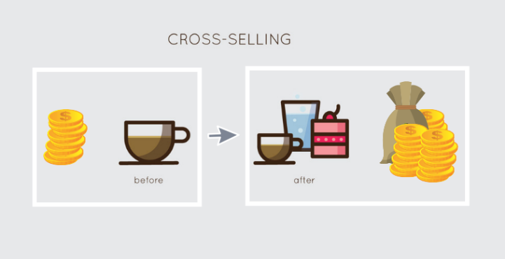

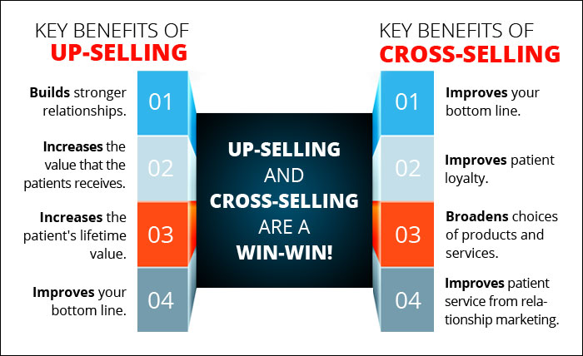

BUSINESS UNDERSTANDING

XYZ is a Latin American credit union company which is known for their banking products. But they think that their existing customers aren’t using more than 1 of their services which hits their revenue. This indicates that the firm is not showing significant developments via Cross selling. Even though ABC company came up with a frame work involving Machine Learning, the task of the data analyst is to achieve the same using the data provided and perform various operations on it to provide useful recommendations without the help of ML.

PROJECT LIFE CYCLE

As a data analyst I need to inspect the data and give suggestions to the bank for actions to take to increase cross selling (without using ML). The Project consists of seven main steps namely

1. Business understanding
2. Data Understanding
3. Data Cleansing and Transformation
4. Exploratory data analysis
5. EDA Recommendation (and hypothesis testing if needed)
6. Data Visualization using a dashboard
7. Final Presentation

The Dashboard should capture type of customer their count, segment wise (VIP,student etc) customer average age and other KPIs which gives better business insight in taking the final decision.

DATA INTAKE REPORT

Name: Deepthika Shiwani Muralikrishnan, Payal Upadhyay, Abida S Bhatti

Report date: 23/07/2021

Internship Batch: LISUM01

Version: 1.0

Data intake by: Deepthika, Payal, Abida

Data intake reviewer: Deepthika, Payal, Abida

Data storage location: <https://drive.google.com/file/d/16-nzZR91-ijrfjUcI2PniTpOgrvFAykA/view>

**Test.csv**

|  |  |
| --- | --- |
| **Total number of observations** | 929615 |
| **Total number of files** | 1 |
| **Total number of features** | 24 |
| **Base format of the file** | .csv |
| **Size of the data** | 110290743 bytes |

**Train.csv**

|  |  |
| --- | --- |
| **Total number of observations** | 13647309 |
| **Total number of files** | 1 |
| **Total number of features** | 48 |
| **Base format of the file** | .csv |
| **Size of the data** | 2292759599 bytes |